MODULE END ASSIGNMENT
“ANALYZING E-LEARNING PLATFORM PURCHASES USING MYSQL”

1. Created the database and schemas.
Created a Database for this project
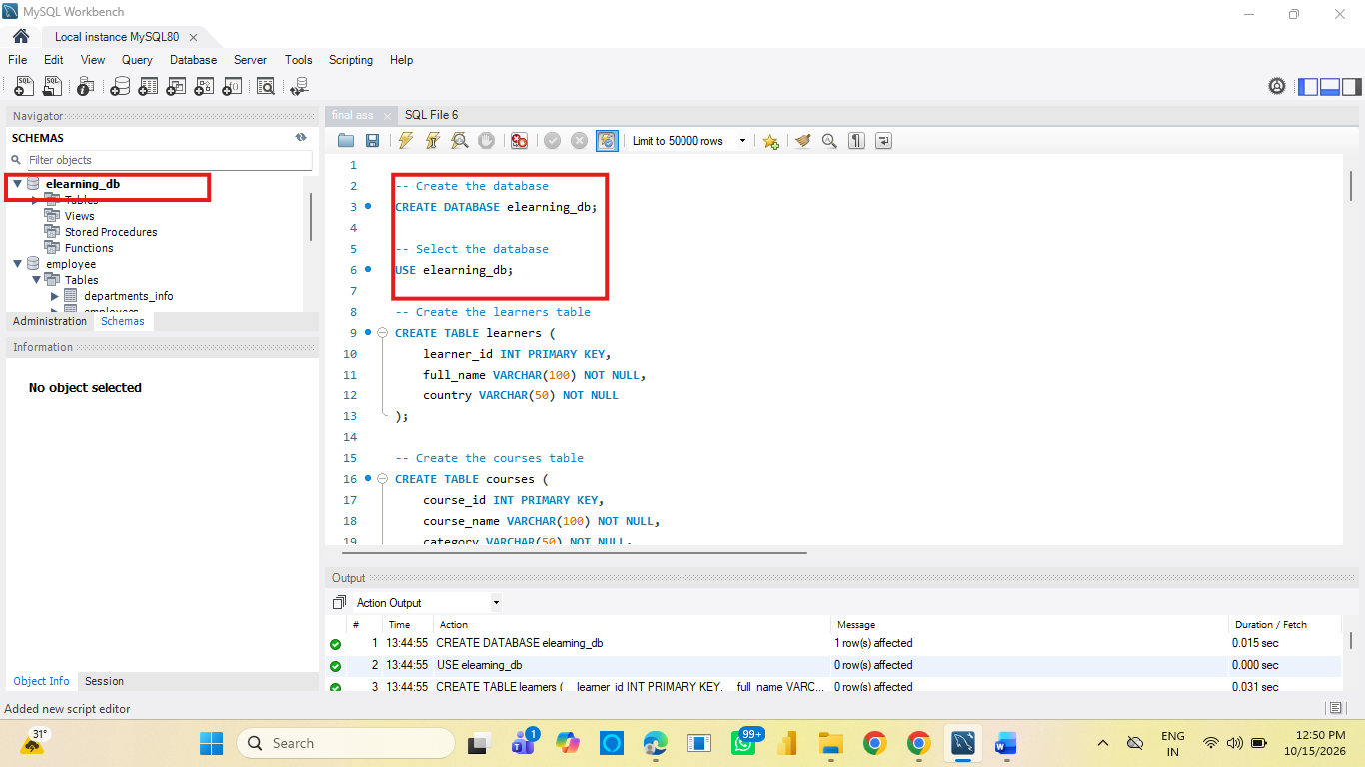
Create all three tables in MySQL with appropriate data types and relationships.
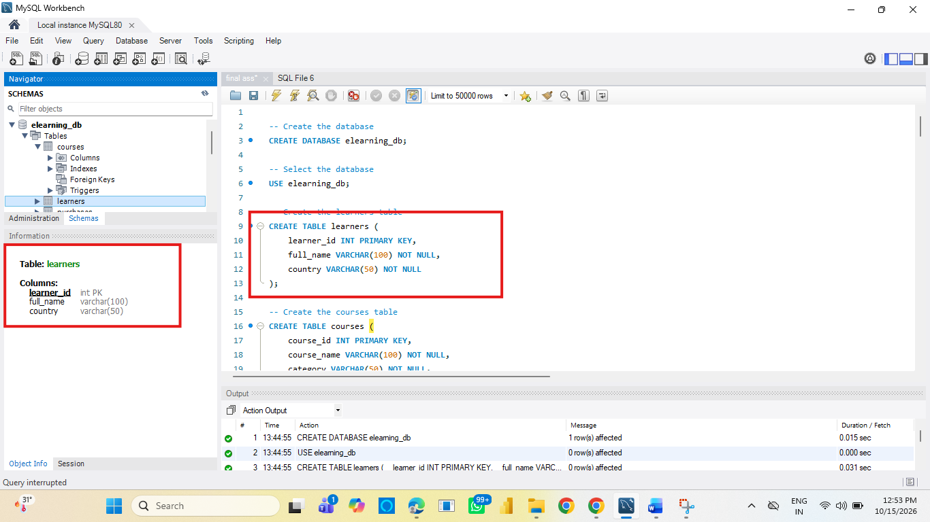
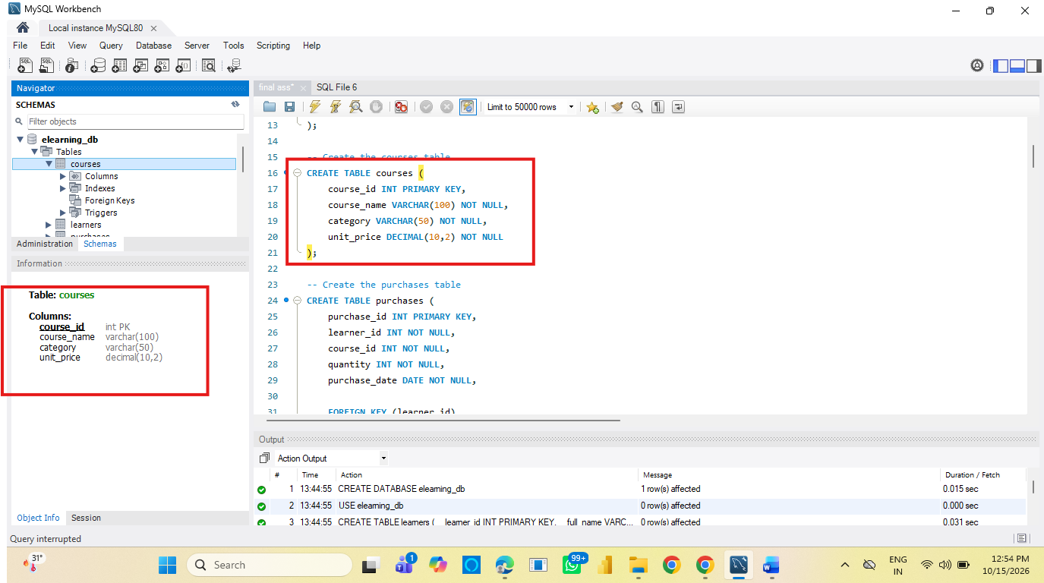

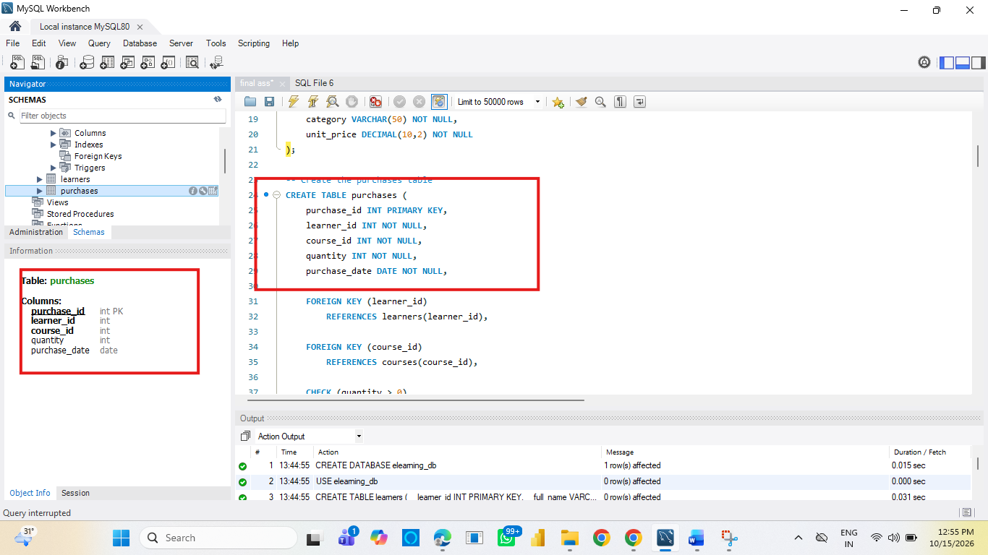

Inserted sample data
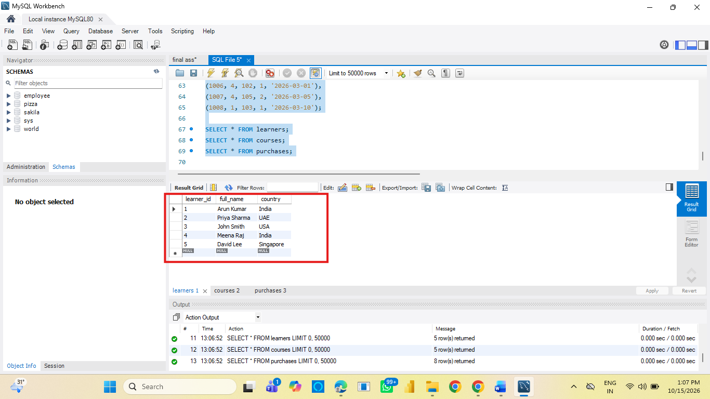
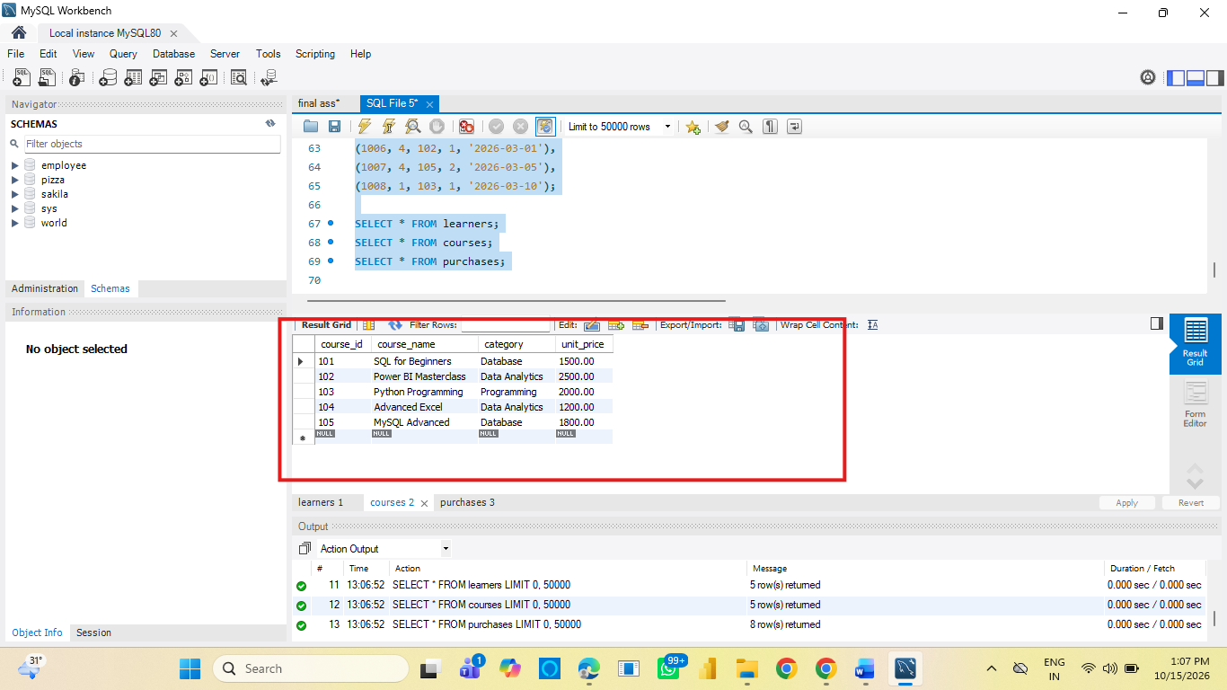
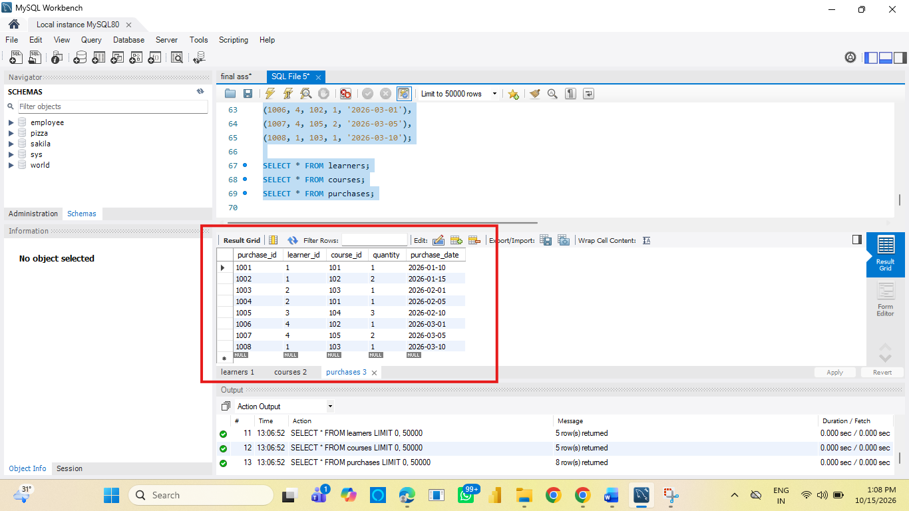

2. Data Exploration Using Joins
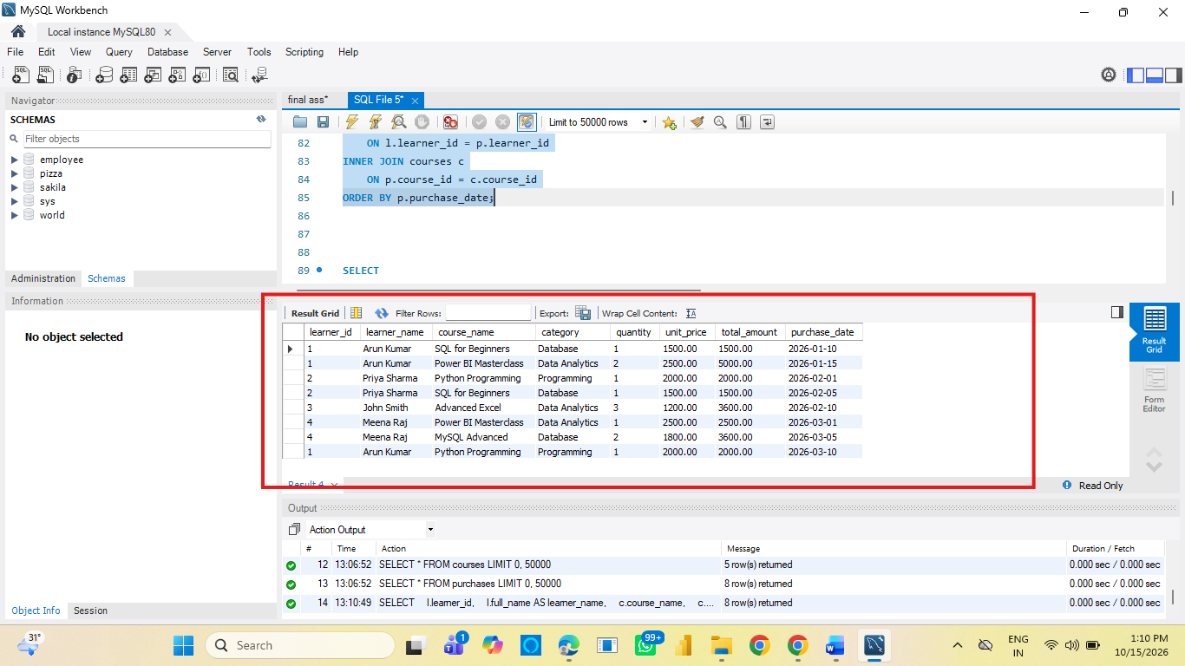

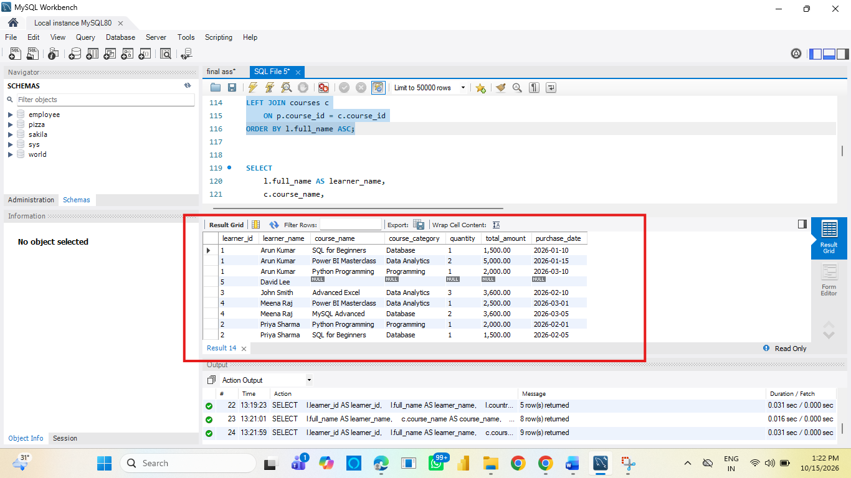

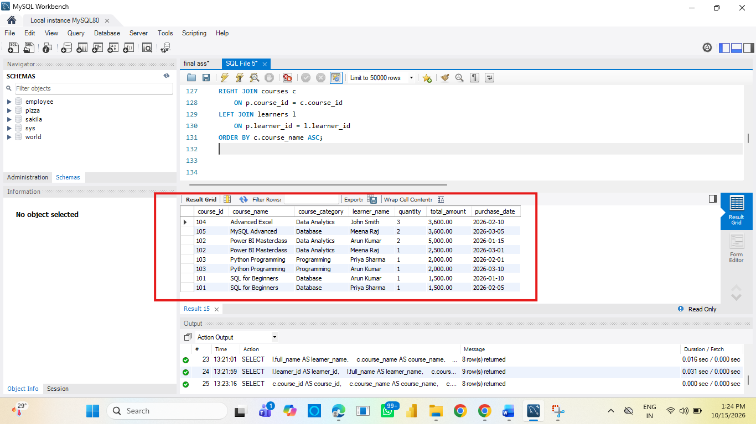

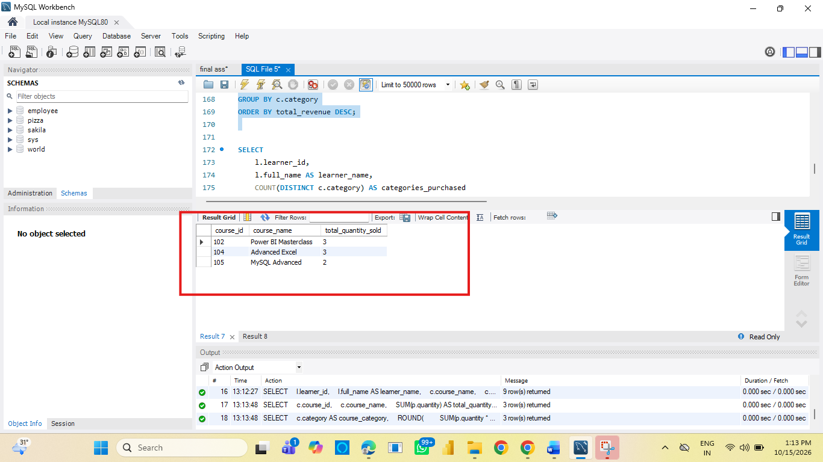

3. Analytical Queries

1. Display each learner’s total spending (quantity × unit_price) along with their country.
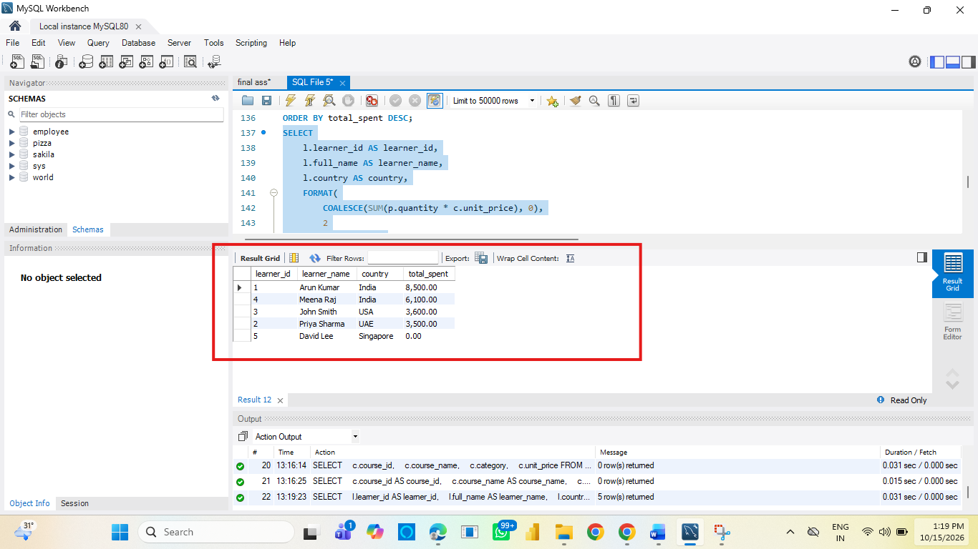
Q2. Find the top 3 most purchased courses based on total quantity sold.
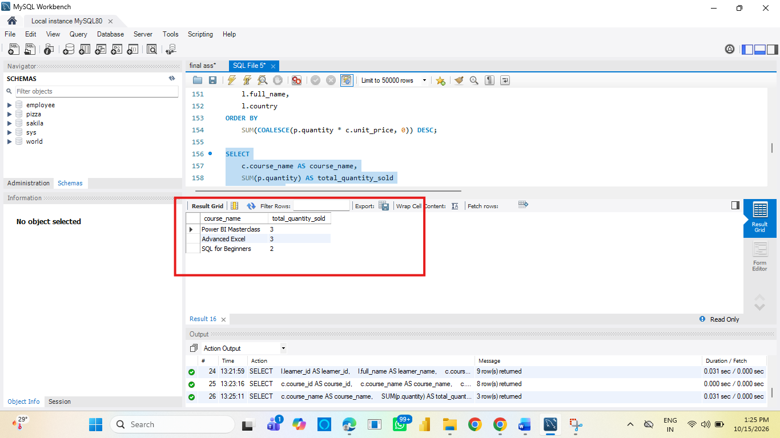

Q3. Show each course category’s total revenue and the number of unique learners who purchased from that category.
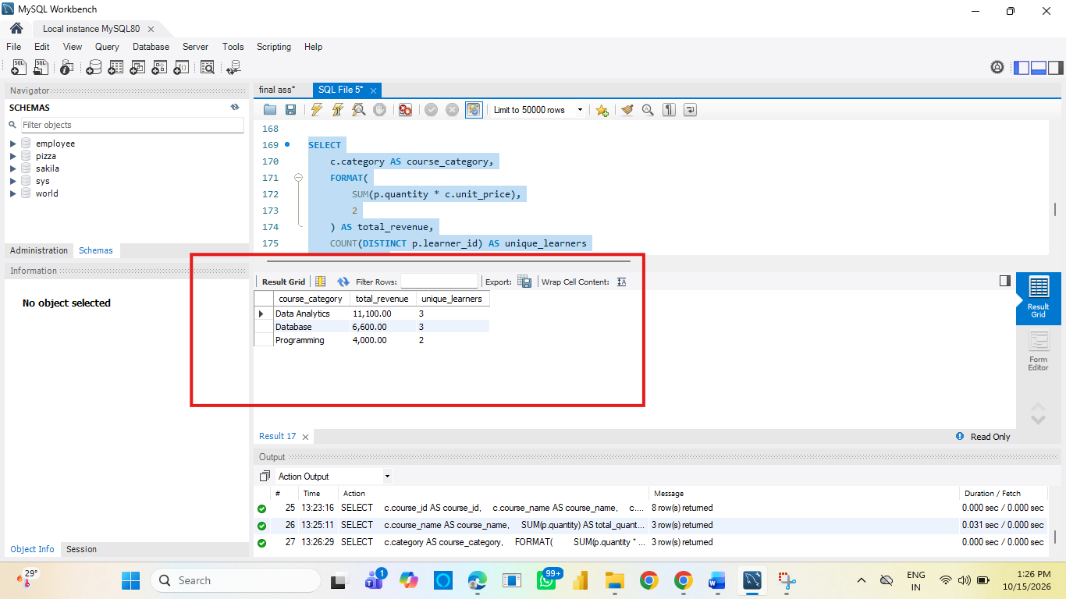
Q4. List all learners who have purchased courses from more than one category.
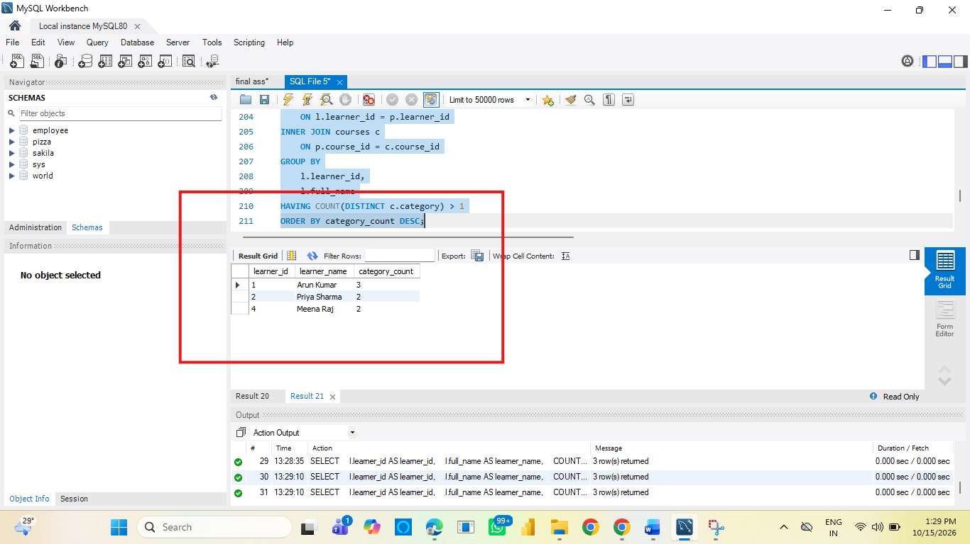
Q5. Identify courses that have not been purchased at all.
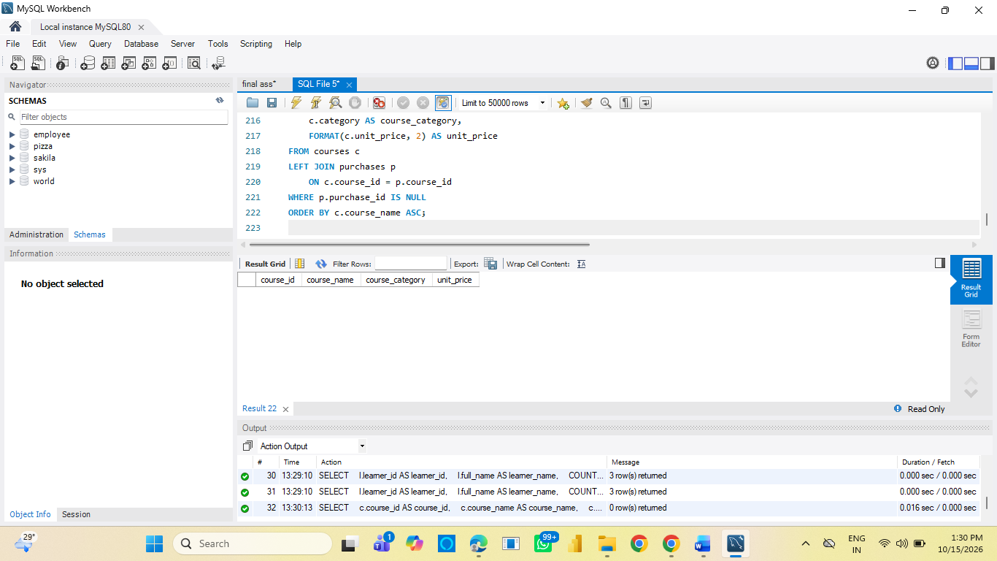

Key Insights
• Revenue by category: Data Analytics generated ₹12,000 (48% of revenue), Database generated ₹11,000 (44%), and Programming generated ₹2,000 (8%). Data Analytics was the leading category.
• Popular courses: MySQL Basics sold 4 units. Power BI and Excel for Beginners sold 3 units each. Advanced SQL sold 2 units.
• Learner spending: John Smith spent the most (₹8,000), Arun Kumar (₹7,500).
.
Recommendations
• Prioritize marketing for Data Analytics and Database courses, which together account for 92% of sample revenue.
• related courses—for example, MySQL Basics with Advanced SQL, or Power BI with Excel—to encourage repeat purchases and cross-category learning.
• Run a targeted promotion or collect learner feedback for Web Development before investing further in broad advertising.
Conclusion
The sample records show ₹25,000 in revenue from 13 course units. Data Analytics and Database are the strongest categories, while Web Development needs attention. These findings are based on the illustrative dataset supplied for the MySQL project; validate them against the platform’s full transaction data before making business decisions.

